**Business Overview**

**Let’s Get Outdoors** - Dropshipping Business - hunting, fishing and outdoor equipment. URL: https://www.letsgetoutdoors.com

The site has been built on Bigcommerce. Currently operates with 3 suppliers that are located in the US and has 130k skus offered on the site. Most traffic is coming organically through ebay and the website currently.

Owner spends no money on ads (see P&L’s), which would be a huge area for growth with this business.

**From the owner:**

I spend 30 minutes to 1 hour per day - Qty, pricing, orders, and tracking are all automated.

Normal supplier contracts in place. You have to be a business with an EIN/Sales Tax ID. There are no term limits. If you pay your bills you keep your account open.

**Highlights:**

- 2023: Revenue - $276,565 - Net Profit - $50,000

- 2024: Revenue - $386,240 - Net Profit - $70,000

- 2025: Revenue YTD - $142,000

- All products dropshipped - owner doesn’t handle any product

**Products**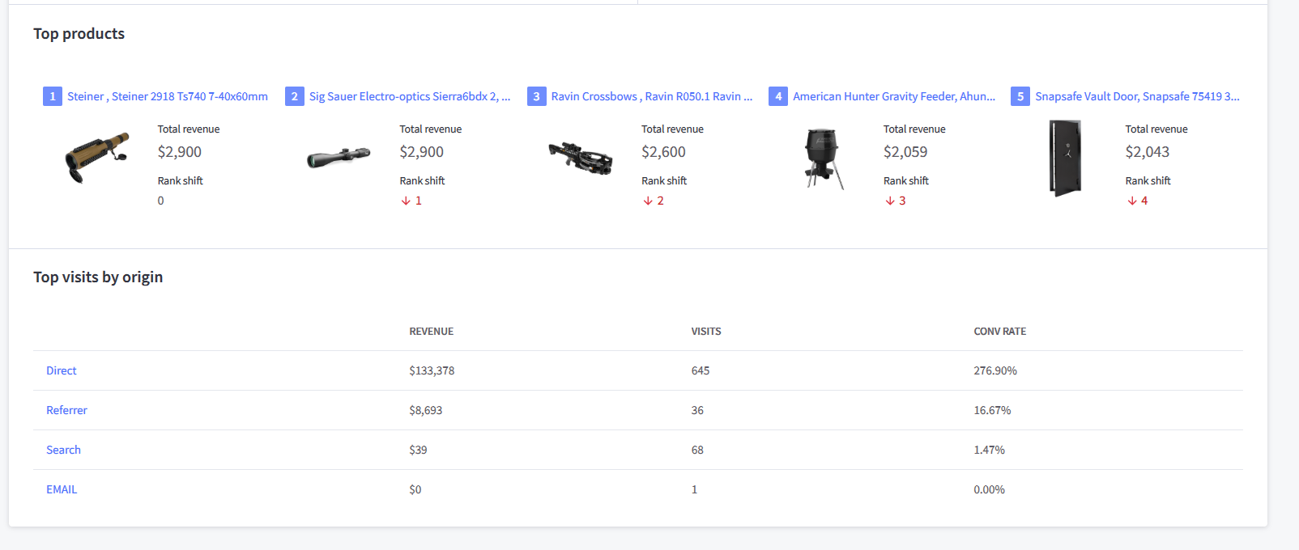

**2025 Revenue**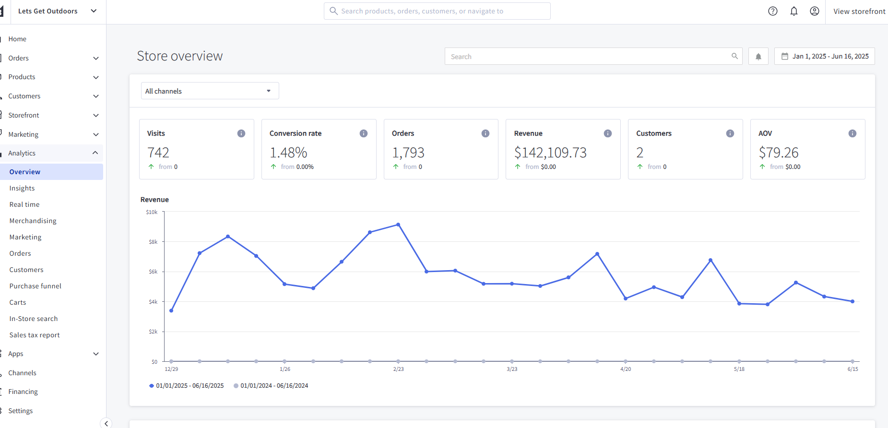

**Traffic sources**

